RULE BOOK: SURVEY TREASURE HUNT – AVALOKAN '26
DEPARTMENT OF CIVIL ENGINEERING, BIT SINDRI, DHANBAD

I. Event Overview
The Survey Treasure Hunt is a technical navigation event designed to challenge participants through surveying-based puzzles, field tasks, and intellectual decoding across the campus.
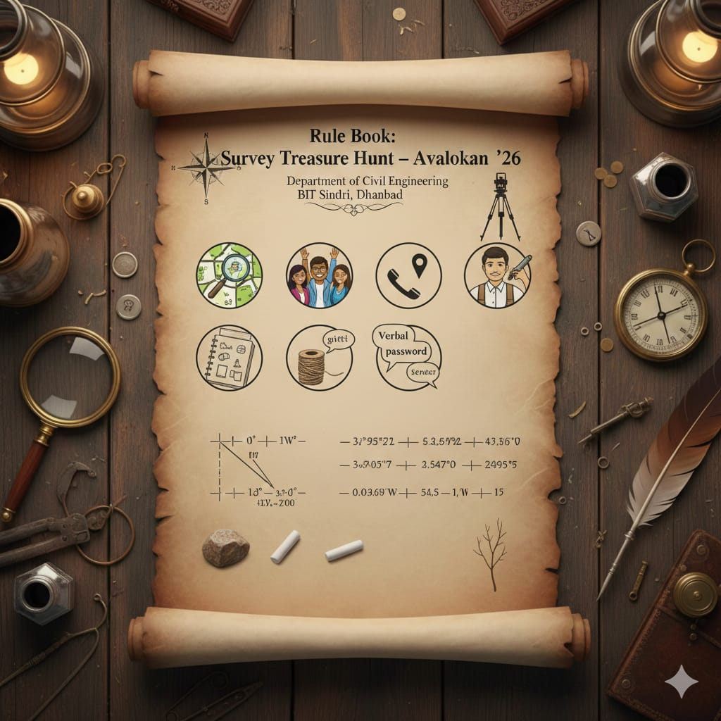
II. Team Formation & Identity

Capacity: The event is limited to a total of 5 teams.

Composition: Each team consists of up to 5 members, formed by randomly mixing first and second-year students.

Structure: Teams are organized into separate male and female groups; custom selection is not permitted.

Identity: Every team must adopt a unique one-word name.
Naming Convention: The starting letter of each team name must be distinct from all other teams.

III. Operational Logistics & Tracking
Boundaries: The event commences at the Gate of the Civil Engineering department and concludes at the department’s Garden.

Live Tracking: Team leaders must share their live location via WhatsApp for the duration of the event.

Device Policy: Only the team leader is permitted to use a mobile phone; only one device is allowed per team.

Technical Assistance: Use of Google Maps, ChatGPT, and passwords for decoding is explicitly permitted.

Identification: Seniors will mark the team’s first letter on the nails of all members at the start of the journey.
IV. Rules of Conduct & Disqualification Risks

Authority: Teams must complete specific tasks assigned by seniors at various stations as part of the game.

Independent Logic: Teams must rely on their own problem-solving abilities; excessive consultation with seniors may lead to disqualification.

Zero Collaboration: Communication or resource sharing between different teams is strictly prohibited.

Full Participation: Every team member is required to participate in all activities.

Resource Integrity: Losing any assigned materials (cheat sheets, threads, etc.) will result in elimination.

Professionalism: Misbehaviour toward seniors or judges will not be tolerated and results in immediate disqualification.
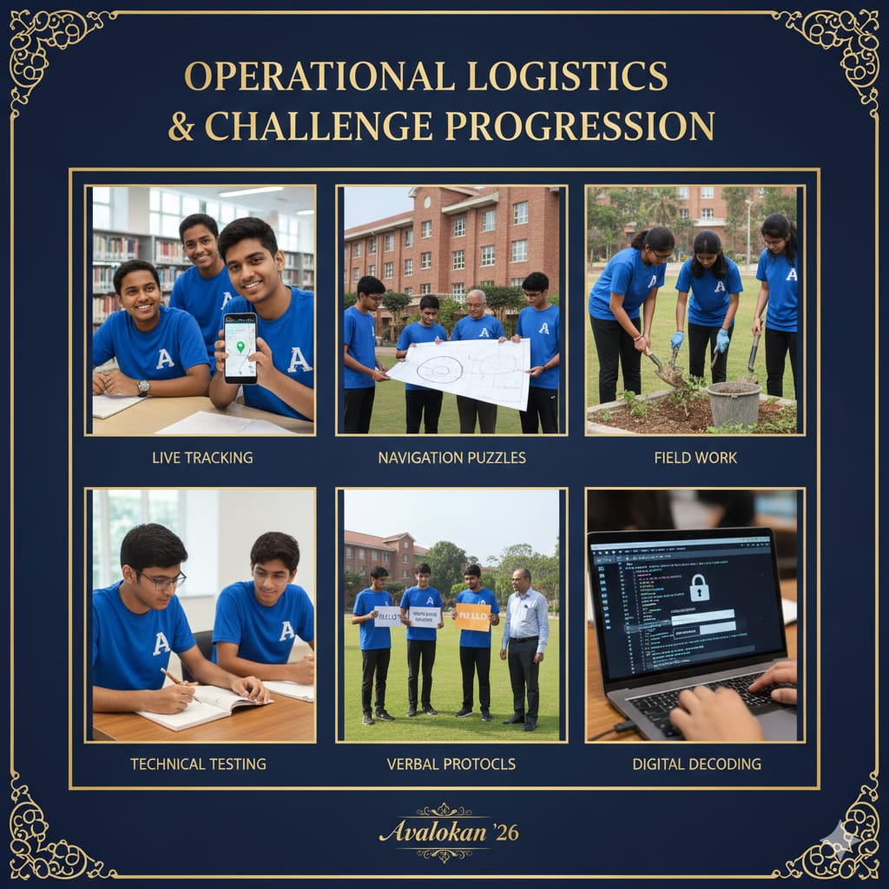

V. Challenge Progression

Initial Draw: Team leaders draw "Cheat Sheet 1" to determine their first direction and receive a secret "Cheat Sheet 5" (Bonus Card) required for the final level.

Technical Testing: At designated checkpoints, teams must pass oral MCQ tests or technical dictation related to Civil Engineering to progress.

Navigation: Teams must solve coordinate-based puzzles (calculating Latitude and Longitude) to identify subsequent locations.

Communication Protocols: Teams must perform specific verbal password exchanges with officials (e.g., at the Canteen) to verify their identity and receive rewards.

Field Work: Teams must perform assigned labour, such as preparing top-view sketches or collecting specific environmental materials, to earn advanced clues.

Digital Decoding: The final leg requires decoding ASCII function texts to unlock a password-protected PDF and locate the final treasure.

VI. Final Validation & Winning Criteria

To be successfully validated at the final destination, the arriving team must:

Item Check: Present all mandatory collected items as Nail marks, Journal Thread, Gitti (small stone), Chalk, and the final collected material.

Verbal Authentication: Correctly execute the final password exchange:
Senior: "HELLO (BOOM-BOOM) OVER"
Team: "HELLO (WIN-WIN) OUT".

Official Sign-off: Complete the master list verification and provide the team leader's signature.
